***March 19, 2018***



***Central Lutheran School***

4th Grade News

***Miss Keuning***

**A Glance at Upcoming Events**

* March 19th-23rd – Anti-Bullying Week
* Friday, March 23rd – 1:15 Dismissal
* Thursday, March 29th – VIP DAY – 1:15 Dismissal – NO BUSSES (KFJ is available)
* March 30th & April 2nd – No school
* Wednesday, April 4th – 1:15 Dismissal
* Thursday, April 5th – Fine Arts Night

**Memory Work**

**For Tuesday:**

Matthew 21:9

And the crowds that went before him and that followed him were shouting, “Hosanna to the Son of David! Blessed is he who comes in the name of the Lord! Hosanna in the highest!”

**For Friday:**

Matthew 26:26-28

Now as they were eating, Jesus took bread, and after blessing it broke it and gave it to the disciples, and said, “Take, eat; this is my body.” And he took a cup, and when he had given thanks he gave it to them, saying, “Drink of it, all of you, for this is my blood of the covenant, which is poured out for many for the forgiveness of sins.

**Reading**

This week we will be reading a story about heroes and talking about what makes someone a hero. We will focus on the theme of stories, writing letters, especially thank you notes, and continue to review and make connections to reading concepts that we have covered earlier in the year.

**Grammar**

This week we will be reviewing adjectives and adverbs. We will be learning about comparative and superlative adjectives and adverbs.

**Math**

We will be learning about mass and weight, classifying triangles, lines of symmetry, and division with zeroes in three-digit There will be a math test on Friday.

**Social Studies**

We’re moving on to a new chapter in social studies this week, continuing our journey through the United States into the Southeast. We are also continuing to practice learning out states and capitals – remember it’s our goal that the 4th graders know all the states and capitals by the end of the year.

**Science**

We will not have science this week, as we will be focusing on our new chapter in social studies. Our next unit will be on space.

**Spelling**

There will be a spelling pre-test on Monday this week and a final test on Friday. This week the focus is on the Greek roots that we will be talking about in class.

telephone microchip

biography telegraph

telescope perimeter

photograph paragraph

microwave phonics

diameter symphony

barometer saxophone

microscope periscope

headphones megaphone

microphone autograph

**Challenge Words**

stethoscope xylophone microbe cacophony microorganism

**Religion**

This week we will be going through some lessons on how to be a good friend, work through conflicts, and solve problems according to the way Jesus would have us do it. This will tie in with our Anti-Bullying week.

**Red Folders**

Your child’s graded papers from last week will be in his/her red folder, along with any announcements. Please take time to look through these with your child.

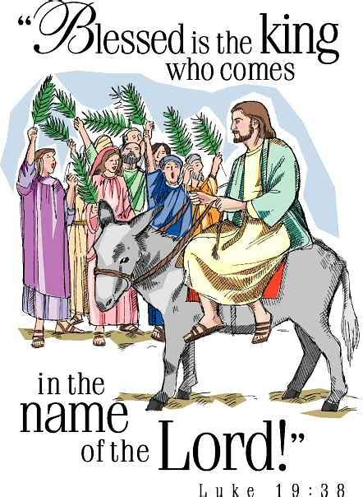

**Book Orders**

Book orders for the month of March are due on Friday!!! (March 23rd)

**Field Trip Information**

Our field trip to Living History Farms and the Capitol is coming up on April 13th. Please watch for information and permission slips to come home this week.

**Have a blessed week!**

Miss Keuning