***February 5, 2018***



***Central Lutheran School***

4th Grade News

***Miss Keuning***

**Upcoming Events**

* 12:15 Dismissal this Friday
* 1:15 Dismissal Wed., Feb. 14th
* Valentine’s Day Parties Feb. 14th
* Monday, Feb. 19th – NO SCHOOL
* 1:15 Dismissal Wed., Feb. 28th

**Memory Work**

**For Tuesday:**

John 6:37

All that the Father gives me will come to me, and whoever comes to me I will never cast out.

**For Friday:**

Matthew 19:14

but Jesus said, “Let the little children come to me and do not hinder them, for to such belongs the kingdom of heaven.”

**Reading**

This week we will be reading the story *Navajo Code Talkers.* We will be working on sequences in stories, pronouns and antecedents, root words, and new vocabulary. Our story this week is non-fiction.

**Grammar**

This week we will be working on pronouns and antecedents. We will also be talking about writing instructions/directions.

**Math**

This week the students will be learning about fractions, two-step equations, exponents, polygons, and division with two-digit answers.

**Social Studies**

We will begin chapter 4 this week. This chapter and the following ones will begin taking the students on a journey around the United States, studying weather, scenery, famous landmarks, and other interesting and unique facts about the different states.

We will continue to study the state names, capitals, and their locations.

**Science**

We will take a break from science this week, before starting a new unit, and focus on our social studies chapter, exploring the Northeast.

**Spelling**

The students will take their pre-test on Monday and their final test on Friday. This week our words focus on different spellings of the “sh” sound.

nation tradition

special gracious

lotion extension

mansion addition

precious caution

creation official

vacation solution

tension suspension

especially politician

motion portion

**Challenge Words**

comprehension physician artificial

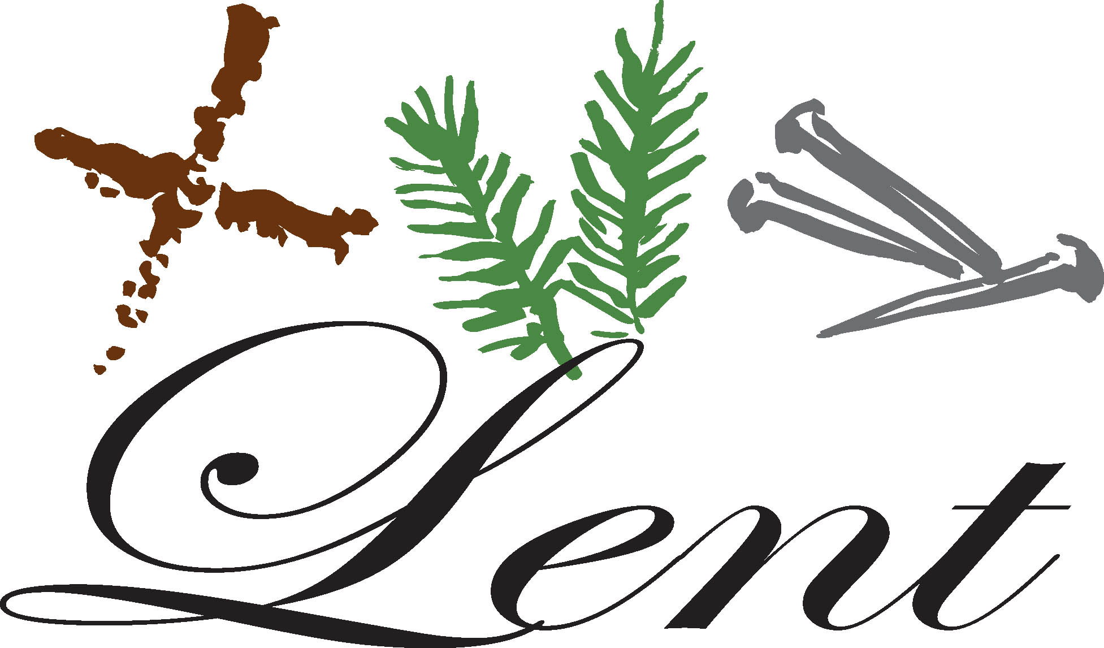

contraction competition

**Religion**



We will be learning about the prophets and Daniel this week.

This trimester our chapel offerings will be going to Lead A Child.

**Red Folders**

Your child’s graded papers from last week, along with classroom and office announcements will be in his/her red folder. Please take time to look through these with your child.

**Book Orders**

With Iowa Assessments, I forgot to send home the February book orders last week, so I will send those out this week.

Book orders for the month of February are due **this Friday, February 23rd**.



Please remember that you can order either with a check and the paper order form or online through Scholastic’s website. All of the information and codes are listed on the classroom website.

**Winter Temperatures**

With the snow coming, it looks like we’ll have some good days to play outside. Please make sure your child has:

* Winter coat



* Snow pants
* Snow boots
* Warm gloves/mittens
* Hat

**Have a blessed week!**

Miss Keuning

